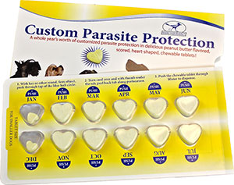
Custom Parasite Protection E-Mail Form

Canine Name:

Breed:

Food/Drug Allergies:

Health Conditions:

Owner’s Name:

Address:

City,State,Zip:

Animal Weight:

This is a PDF Form. Print it off, fill it out, fax it to 770-459-2706, or bring it directly to the office.

